HOS02A Intro to Docker
  - AI500 – Artificial Intelligence of Cloud Computing
by Verónica Elze in Summer 2024
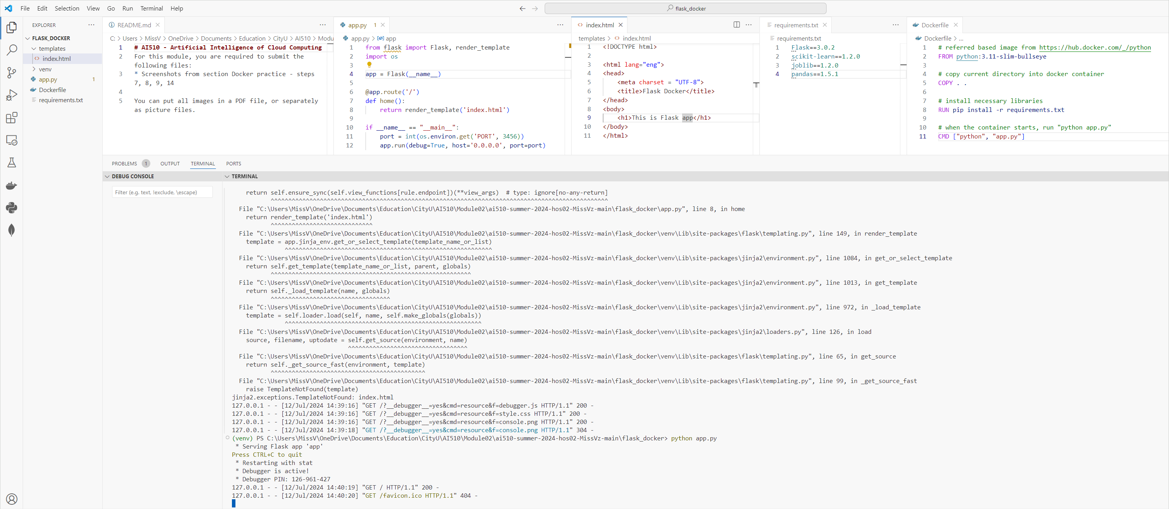
Figure 1 Step 7 Create Dockerfile

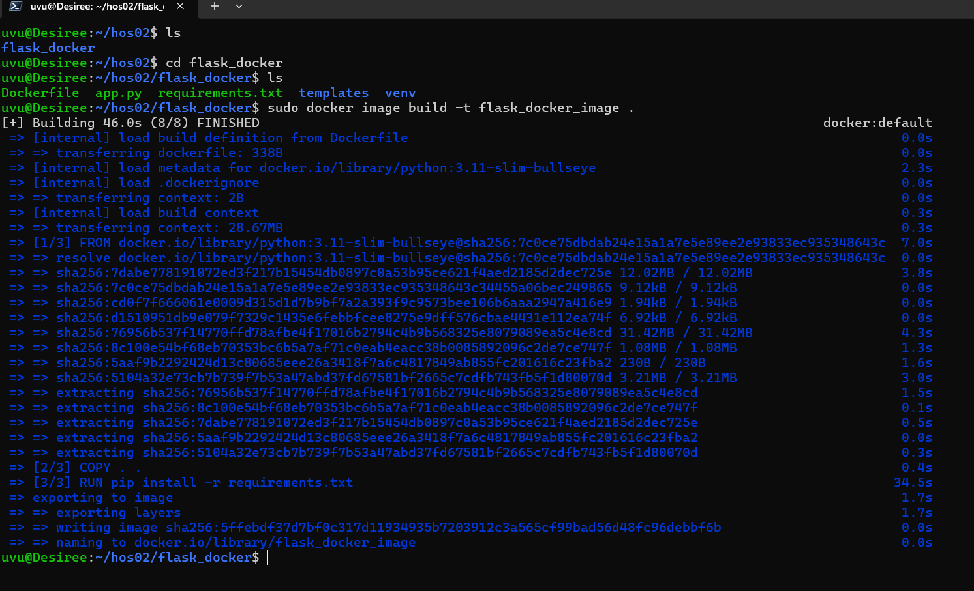
Figure 2 Step 8 Build Docker image

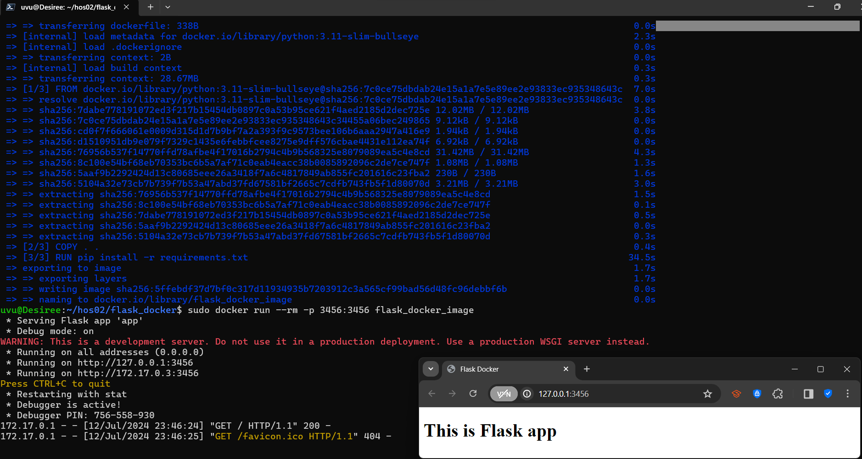
Figure 3 Step 9 Start Docker image
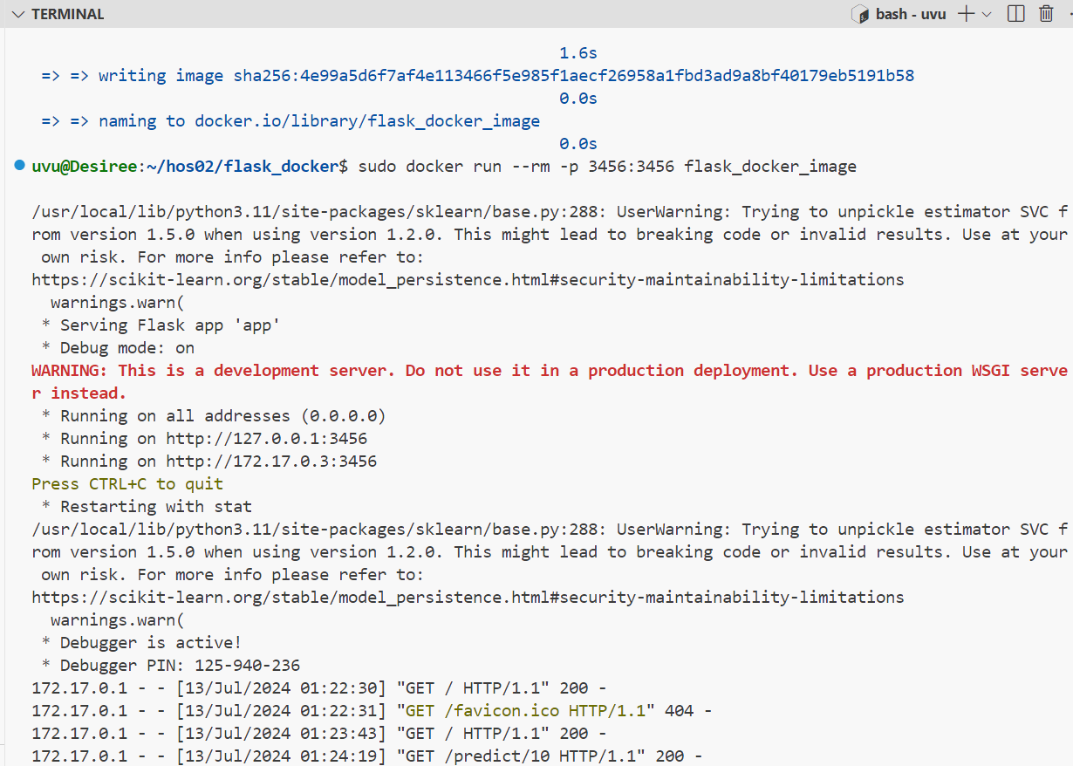
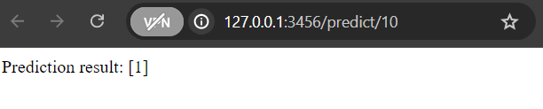
Figure 4 Step 14 Test predict path

